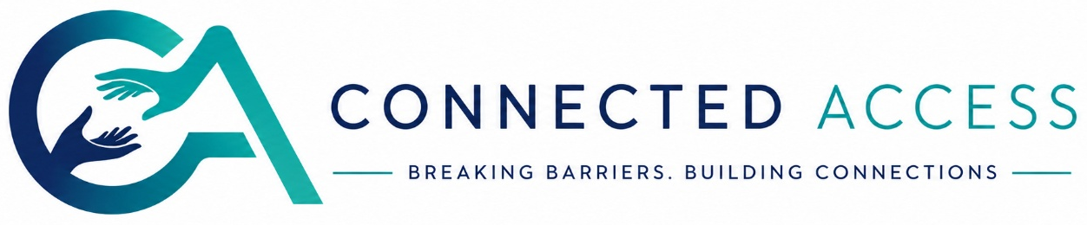

Connected Access Interpreter Registration
  - Internal onboarding document
Welcome
Thank you for your interest in working with Connected Access Interpreting.
As part of our onboarding process, we ask every interpreter and trainee interpreter to complete a short skills review. This is not a formal assessment, and we are not an assessment centre. The purpose is simply to help us maintain a consistent, high standard of interpreting across the agency so that we can confidently match interpreters to the assignments we receive.
We recognise that every interpreter brings different experiences, strengths and areas of expertise. Whether you're newly qualified, an experienced practitioner, or currently completing your training, we hope this process gives you an opportunity to showcase your skills and begin a positive working relationship with us.
Why we do this
This review helps us:
- Understand your interpreting style and strengths.
- Standardise quality across our interpreting pool.
- Match you with bookings that suit your experience and expertise.
- Identify opportunities to support your professional growth within the agency.
It is not designed to rank interpreters or determine professional competence beyond our internal onboarding process.
Confidentiality & GDPR
Your written responses and video submission will be used solely by Connected Access for onboarding purposes.
- Your information will remain confidential and stored securely.
- It will not be shared with clients or third parties without your consent.
- Your submission is processed in accordance with the UK GDPR and the Data Protection Act 2018.
- If you choose not to proceed with onboarding, you may request deletion of your assessment materials.
Professional Standards & Requirements
Connected Access is committed to delivering safe, ethical and high-quality interpreting services. As an agency, we operate in line with the NRCPD Code of Conduct and ethical guidance, and we expect all interpreters working through Connected Access to uphold the same professional standards.
To join our interpreting pool, you must:
- Hold a current professional registration such as NRCPD or RBSLI, where applicable to your practice.
- Hold valid professional indemnity and public liability insurance in your own name.
- Provide evidence of both registration and insurance during onboarding.
Please note: we are unable to complete your onboarding or offer assignments until proof of both documents has been received and verified.
If, at any point whilst registered with Connected Access, your professional registration or insurance lapses, you will be temporarily removed from our active interpreter pool while the matter is reviewed. This is to protect interpreters, clients and the integrity of the service. Where appropriate, interpreters may be reinstated once valid registration and insurance have been renewed and verified.
Thank you for helping us maintain a professional, safe and trusted service for everyone.
Interpreter Profile
Full name (as it appears in online form/ registration):

A few questions
1. What inspired you to learn British Sign Language and pursue interpreting?
A few sentences is perfect.
2. What has been your most rewarding experience as an interpreter so far?
This could be a memorable booking, a meaningful interaction, or a moment that reminds you why you enjoy the profession.
Video Submission
3. One-minute interpreting task
Please record a maximum 1-minute video interpreting the passage provided by Connected Access.
Guidance:
- Interpret naturally as you would in practice.
- We are looking at overall communication, clarity and professionalism rather than perfection.
- You may record the video as many times as you wish before submitting.
- Please do not use AI or edited interpretation overlays.
Source text: To be provided by Connected Access.
Thank you.
We genuinely appreciate the time you've taken to complete this review.
One of our beliefs in building Connected Access is that all interpreters deserve to work with an agency that sees and values the work you do, strives on friendly and diligent professionalism, open and honest communication and mutual respect. We hope this is the beginning of a positive working relationship, and we look forward to seeing what you bring to our interpreting community.

Save this document and send to
Email: onboarding@connectedaccessinterpreting.co.uk
Video submissions send to
WhatsApp (__________) please remember to include your name in the message!

Connected Access
Breaking Barriers – Building Connections

