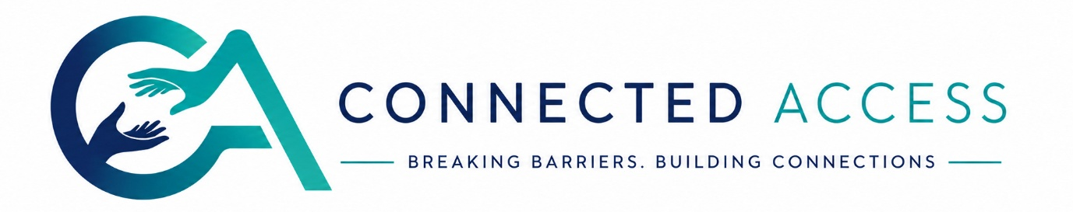

Privacy Notice (UK GDPR)
  - Connected Access Interpreting Privacy Notice

1. Our commitment
Connected Access is committed to protecting the privacy of Deaf people, clients, interpreters and organisations.
We process personal information in accordance with the UK General Data Protection Regulation (UK GDPR) and the Data Protection Act 2018.

2. What information we collect
We may collect:
Personal data | Why
Name | Identify service users
Contact details | Booking communication
Organisation | Arrange appointments
Venue details | Deliver the assignment
Communication preferences | Provide accessible services
Invoice information | Billing and payment
We only collect information necessary to deliver interpreting services.

3. How we use your information
Your information is used to:
- Arrange interpreting assignments
- Match appropriate interpreters
- Contact you about bookings
- Produce invoices
- Meet safeguarding and legal obligations
We do not sell personal data or use it for third-party marketing.

4. Confidentiality
Interpreters working through Connected Access are contractually required to maintain strict confidentiality and adhere to the NRCPD Code of Conduct. Information disclosed during interpreted appointments must remain confidential except where disclosure is legally required, including safeguarding situations.

5. Data sharing
We may share limited information with:
- The assigned interpreter
- The booking organisation
- Accountancy providers for invoicing
- Legal authorities where required by law
We will never share unnecessary personal information.

6. Data retention
Record | Typical retention
Booking records | 7 years
Invoices | 7 years
Interpreter onboarding documents | Duration of engagement + 6 years
Marketing enquiries | 12 months
Retention periods may vary where legal requirements apply.

7. Your rights
You have the right to:
- Access your data
- Correct inaccurate information
- Request deletion where appropriate
- Restrict processing
- Object to marketing communications
Requests should be made in writing to Connected Access.

