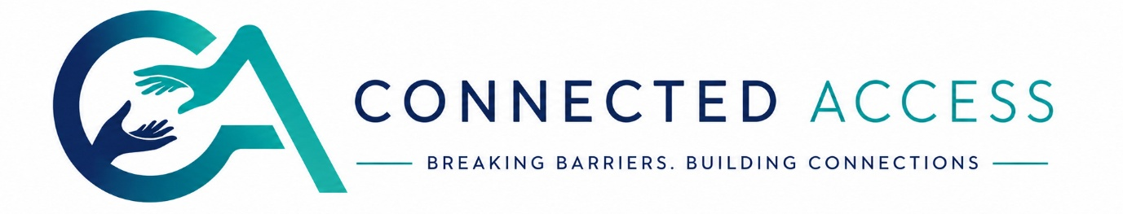

Client Terms & Conditions
  - Connected Access Interpreting Terms & Conditions for Organisations and Service Users

1. Our Service
Connected Access provides professional British Sign Language (BSL) interpreting and communication support services across healthcare, education, public sector, workplace and community settings.
We coordinate freelance interpreters who meet our onboarding requirements. Wherever possible, assignments are fulfilled by NRCPD-registered professionals working within their scope of competence and professional standards.

nrcpd.org.uk

2. Booking Confirmation
A booking is only confirmed once:
- A completed booking request has been received
- Fees have been agreed
- An interpreter has accepted the assignment
- Written confirmation has been issued by Connected Access
Verbal discussions or enquiries do not constitute confirmation.

3. Minimum Booking
Our minimum booking is 3 hours per interpreter.
This includes professional preparation, travel time where applicable, and the reserved availability of the interpreter.

4. Two-Interpreter Policy
Connected Access may assign two interpreters where required for safe and effective practice.
This commonly applies to:
- Appointments over one hour of continuous interpreting
- Conferences and training events
- Mental health settings
- Complex clinical discussions
- Legal or emotionally demanding assignments
The decision is based on professional standards and interpreter welfare.

5. Cancellation Policy
Notice period | Charge
15+ calendar days | No fee
8–14 calendar days | 50%
Less than 7 calendar days | 100%

Cancellation charges apply because interpreters reserve time specifically for your booking.
Any agreed travel costs already incurred may also be charged.

6. Changes to Bookings
Clients must notify us immediately if there are changes to:
- Date or time
- Venue
- Deaf participant
- Communication preferences
- Nature of the appointment
Significant changes may require a different interpreter or revised quotation.

7. Client Responsibilities
Clients agree to:
- Provide accurate booking information
- Share relevant preparation materials where available
- Ensure interpreters have safe access to the venue
- Provide appropriate breaks for longer assignments
- Inform Connected Access of any safeguarding or security procedures

8. Fees & Payment
Unless otherwise agreed:
- Minimum 3-hour charge applies
- Administration fee applies per booking
- Evening, weekend and bank holiday enhancements may apply
- Payment terms are 28 days from invoice date
Late payment may result in interest and recovery costs in accordance with UK legislation.

9. Complaints
We encourage concerns to be raised within 10 working days.
Complaints will first be managed internally. Where the complaint relates to the conduct of an NRCPD registrant, clients may also use the NRCPD Professional Conduct Complaints Procedure.

nrcpd.org.uk

10. Liability
Connected Access will take all reasonable steps to provide an appropriately qualified interpreter.
We cannot accept liability for delays or cancellations arising from circumstances beyond our reasonable control, including severe weather, transport disruption or incorrect information provided by the client.

