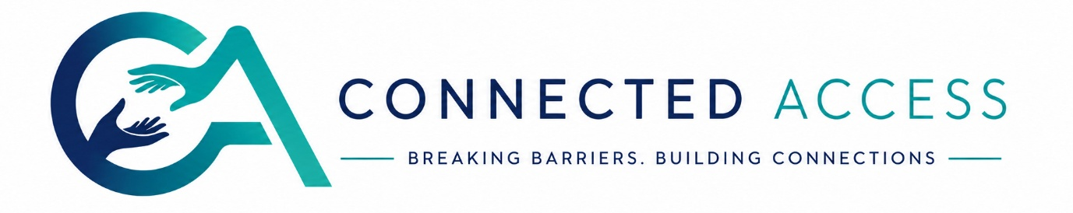

Interpreter Framework Agreement
  - Connected Access Interpreting Freelance Interpreter Agreement

1. Professional Status
Interpreters engaged by Connected Access are self-employed independent contractors.
Nothing within this agreement creates an employment relationship.
Interpreters remain responsible for:
- HMRC tax obligations
- National Insurance
- Pension arrangements
- Professional insurance

2. Eligibility
To accept work through Connected Access, interpreters must maintain:
- Current NRCPD registration (or recognised equivalent where agreed)
- Professional Indemnity Insurance
- Enhanced DBS where required
- Right to work in the UK
Failure to maintain these may result in suspension from our interpreting pool.

nrcpd.org.uk

3. Accepting Assignments
Interpreters should only accept work when they have:
- Appropriate competence
- Relevant subject knowledge
- Sufficient preparation time
- No conflict of interest
Assignments should be declined where they fall outside professional competence, reflecting NRCPD expectations.

nrcpd.org.uk+1

4. Professional Conduct
Interpreters agree to:
- Maintain impartiality
- Interpret faithfully and accurately
- Respect confidentiality
- Behave professionally at all times
- Declare conflicts of interest
- Withdraw appropriately if competence becomes compromised

5. Preparation
Connected Access will provide preparation materials whenever supplied by the client.
Interpreters are expected to review these in advance and request clarification where necessary.

6. Availability
Acceptance of an assignment constitutes a professional commitment.
If illness or emergency prevents attendance, the interpreter must notify Connected Access immediately so alternative provision can be arranged.

7. Invoicing
Interpreters should submit invoices by the 25th of each month.
Approved invoices are normally processed within the monthly payment cycle.
Invoices received after the 25th will roll into the following payment run.

8. Confidentiality
Interpreters must never:
- Discuss assignment content with unauthorised persons
- Retain unnecessary client documentation
- Record assignments without explicit consent
- Share identifiable information via unsecured messaging platforms
This obligation continues after the assignment has ended.

9. Safeguarding
Where an interpreter believes someone is at immediate risk of serious harm, they should follow Connected Access safeguarding procedures and relevant legal guidance.
Confidentiality does not prevent appropriate safeguarding action.

10. Termination
Either party may end this agreement at any time.
Connected Access reserves the right to remove interpreters from its pool where there is evidence of:
- Lapsed registration
- No valid insurance
- Serious misconduct
- Breach of confidentiality
- Repeated failure to meet professional standards
Any concerns will be handled fairly and, where appropriate, with reference to NRCPD professional conduct processes.

nrcpd.org.uk

